Issues and Challenges of Modern Network Security

S Abhishek

U4CSE19147

Amrita Vishwa Vidyapeetham

Rahan Manoj

U4CSE19144

Amrita Vishwa Vidyapeetham

Bikash Chandra

U4CSE19114

Amrita Vishwa Vidyapeetham

Arvind Kumar K

U4CSE19109

Amrita Vishwa Vidyapeetham

Abstract

Network security has become more noteworthy basic to individual PC clients, gatherings, and numerous associations. The web structure itself takes into consideration parts security dangers to emerge. With the enormous prominence of PC network programs, its assurance is moreover procured a serious level of consideration.

Keywords

Network security, Authentication, Intrusion Detection, Security Attacks, Firewall, Penetration.

I. INTRODUCTION

PC networks are regularly a common asset utilized by numerous applications addressing various interests. The Internet is especially broadly shared, being utilized by contending organizations, commonly hostile states, and entrepreneurial crooks. With the presence of the web, wellbeing has turned into an essential test and the historical backdrop of security allows a higher mastery of the development of safety innovation. There is a monstrous amount of individual, modern, naval force, and government records on systems administration frameworks universally.

II. NETWORK SECURITY

A. NETWORK SECURITY DEFINITION

Three categories by the ITU-TX.800 standards:

1. Security attack: any activities that harm information, such as information denial service, message alteration, message replay, camouflage, traffic analysis, message leak, and so on.
2. Security mechanisms are those that are meant to identify and prevent security assaults, as well as to recover a system.
3. Security Service: refers to services that use one or more security methods to guard against security assaults and improve data process and information transfer security.

B. DIFFERENTIATING DATA SECURITY AND NETWORK SECURITY

Data security is the component of wellbeing that permits a client's data to be changed over into limitless data for transmission. Since cryptography occurs at the application layer, application columnists are familiar its presence. Authentication happens on a layer that is over the actual layer. Actual organization - layer protection requires disappointment location, assault identification strategies, and insightful countermeasure strategies. Somewhat, this security component is effective.

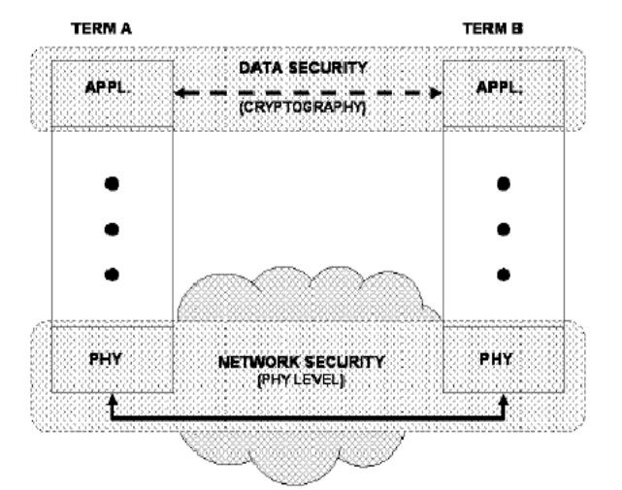

Previously, solid cryptography was promptly broken; notwithstanding, this is not true anymore. Because of the advancement of programmers, cryptographic frameworks should constantly develop to remain one stride ahead. It is worthwhile to utilize a safe organization while trading scrambled text over an organization. This will get the code text, making it doubtful that numerous people will endeavor to break the encryption.

C. NETWORK SECURITY ARCHITECTURE

Network security issue exists through every one of the layers of the PC organization.

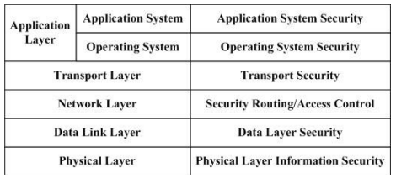

1. Physical Layer Security: is primarily to forestall the harm, listening in and assault on the actual way.

2. Data Link Layer Security: guarantees the information moved through the organization connect from snooping with methods like applies VLAN in LAN and encryption correspondence in WAN

3. Network Layer Security: ensures that the organization just offers approval administrations to approved clients, guaranteeing appropriate organization directing and trying not to listen in or being impeded.

4. Transport Layer Security: gives data stream security.

5. Operating System Security: alludes to the security of working framework access control, like that of an information base server, mail server, or Web server.

6. Application System Security: Because a definitive objective of an organization framework is to support its clients, application framework security is basic. It guarantees security through the application stage's security administrations, for example, correspondence content security, the two sides of correspondence validation, and the inspecting framework.

III. INTERNET ARCHITECTURE AND VULNERABLE SECURITY ASPECTS

Affiliations are conveying secured private associations or intranets in light of stresses over security breaks on the Internet.

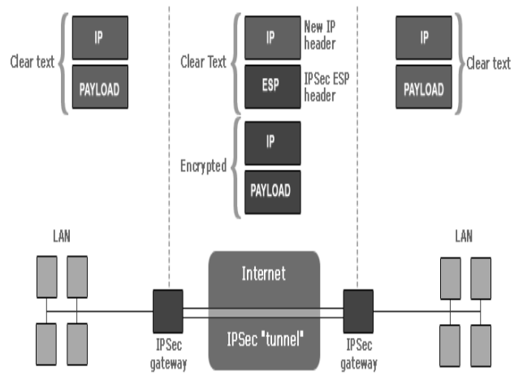

The security implications of the present and approaching interpretations of the Internet Protocol are overviewed. Despite the fact that security exists inside the convention, not all attacks are safeguarded. These attacks are analyzed to decide if further safety efforts are required. The IP Security design of the web convention is a normalization of web security.

IV. NETWORK SECURITY TECHNOLOGY

Security is the security of the organization to get by, just completely safe, organization can understand its own worth. The improvement of organization security innovation as individuals network practice and advancement, it includes specialized is very wide, the fundamental procedures, for example, validation, encryption, firewall and interruption location is a significant safeguard of organization security.

A. VPN Technology

A virtual private organization (VPN) innovation is on the public organization to lay out devoted network, make the information through the security of encryption "pipe" in the public organization. The present VPN fundamentally embraces the accompanying four innovation to guarantee safe: burrow innovation, encryption innovation, key administration innovation and client personality verification innovation and hardware. Among them, a few famous strategies for the PPTP, L2TP burrow and IPsec VPN burrow system ought to be capable to have various degrees of innovation security benefits, the security administrations including different force of source ID, information encryption, and so on. VPN have a few order strategies, like the entrance into the bus VPN also, dial-up VPN; According to the passage convention can be isolated into the second and third layer; According to a way can be separated into supported by the client and the server.

B. Access Control Technology

Access control is the essential system of association security and protection, the standard undertaking is to ensure that not be unlawful usage of association resources and induction to, furthermore is the upkeep of association structure security, to defend the huge strategy for network resources, is one of the vitally focus techniques of association security. As shown by the level of association security, network space environment is special, can be deftly set the total and kind of access control.

C. Authentication Technology

Certificate is a significant innovation to forestall malignant assaults, it is critical to a wide range of data framework security in open climate. The significant affirmation primary methods are: message validation, personality verification and advanced signature. Message validation and personality verification has settled the correspondence parties intrigued by conditions to forestall the harm of an outsider and disguise.

1) Verification data of the shipper is lawful;

(2) To confirm the uprightness of the data to guarantee that the data has not been altered with during the time spent transmission, replay or deferral, and so on.

D. Data Encryption technology

Data encryption process is a substantial execution by an assortment of encryption calculation, to give high security and insurance to the detriment of the more modest. Much of the time, data encryption is the best way to guarantee data privacy. If as per the characterization and the key is something similar to the encryption calculation can be separated into regular cryptographic calculations and public key code calculation? In ordinary secret word, utilize a similar key, the collector and the source is the encryption and decoding keys are something similar or same. In public key cryptography, the recipient and the shipper use keys are something very similar, and it is exceptionally difficult from decoding key encryption key is determined in this paper. By and by, obviously, individuals typically utilize the ordinary secret word and public key cryptography together, for example, utilizing DES or IDEA to encode data, and RSA is utilized to communicate the meeting key.

V. SECURITY DESIGN PRINCIPLE

The plan guideline of organization security assurance framework according to the point of view of the organization security of organization safe security framework plan and execution ought to be as indicated by the accompanying standards:

(1) The least honor rule: any article ought to just have the honor of the item need to finish their appointed assignments, keep away from openness enduring an onslaught, and lessen misfortunes brought about by intrusion.

(2) The standard of guard top to bottom: network security insurance framework is a multi-facet wellbeing framework, keep away from turn into "single disappointment point" in the organization.

(3) The obstructing point guideline: the ideal organization security assurance framework ought to be the wellbeing control focuses in interconnection organization, referred to it as "stifle focuses" here, it works on the organization security the executives, simple to screen network correspondence and review.

(4) Principle: the most fragile connection chain of safety insurance is the fundamental rule of the strength of its most fragile connections, the arrangement is to keep the equilibrium of solidarity.

(5) Failure to safeguard state guideline: the organization security insurance framework disappointment modes ought to be "fall flat - safe" type, specifically, when the disappointment, restart the firewall or breakdown will impede the inward organization security and the remainder of the world.

(6) The default declined to state standard: according to a security perspective, the default declined to state is disappointment insurance state.

VI. VULNERIBILITIES AND EXPLOITS

Vulnerabilities and the strategies important to take advantage of them structure the center of the model. The method depends on modeling the organization credits that lead to weaknesses, then, at that point, dissecting whether the endeavors encoded into the model can exploit the weaknesses to dodge the organization's security. Weaknesses come from many sources and are challenging to dispense with due to a few elements. For an organization to be valuable, it should offer administrations. These services are carried out in programming and it is challenging to ensure that any mind-boggling piece of programming doesn't contain a few imperfections. These defects every now and again convert into security weaknesses. To break into an organization, it isn't adequate to be aware of the weaknesses on the organization. Moreover, before an endeavor can be utilized, its pre-conditions should be met.

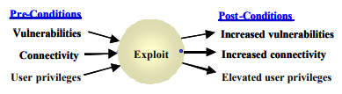

These pre-conditions might incorporate the arrangement of vulnerabilities that the endeavor depends on, adequate client privileges on the objective, adequate client freedoms on the going after host, and organization availability. Aftereffects of a fruitful endeavor could incorporate finding significant data about the network, hoisting client freedoms, overcoming channels, and adding trust connections among other potential impacts.

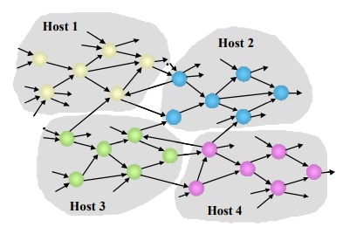

VII. VIRTUAL NETWORK MODEL

Virtual Network altogether influences the VMs interconnectivity which is one of the greatest security challenges in the plan of distributed computing stage. The safer method for segregating each VM is utilizing devoted actual channel for each host-VM interface. Not with standing virtual organization design modes in Xen, typically most hypervisors (i.e., VMware EXSi, Virtual box) offer virtual organization to interface VMs by utilizing scaffold and course. In these modes, the exhibition of between VM correspondence is close local when VMs are running on the same host.

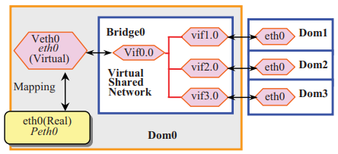

Accordingly, detachment is not difficult to be broken. As indicated by the examination of weaknesses existed in the virtual organization above, we influence the qualities of "course" and "scaffold" modes and consolidate them to propose a novel virtual organization model to make the correspondence among VMs safer. This model is made out of three layers: steering layer, firewall and shared network.

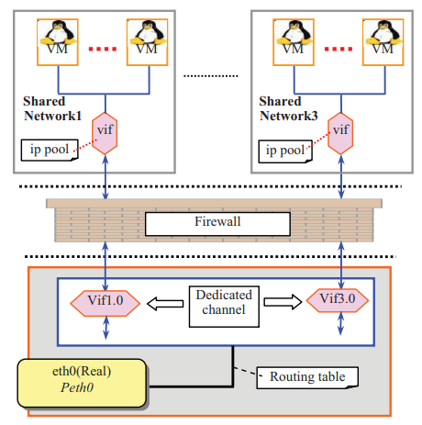

A. Routing Layer

This layer has similar capacities with the customary course mode. It is this layer's liability to interface the physical network and make a legitimate committed channel for the correspondence between the virtual organization and the physical network. In this layer, a bunch of extraordinary static IDs are indicated by the chairman ahead of time and are put away in a design record, which can be allotted to a common organization as an interesting tag.

B. Firewall

The fundamental motivation behind this layer is to forestall parodying assaults sent off from virtual shared networks by distinguishing the organization ID determined in the arrangement record. In this layer, we characterize a bunch of safety strategies for the most part including:

(1) Each virtual point of interaction in the directing layer that associates with a virtual common organization can not speak with some other virtual shared network;

(2) Any packet (i.e., ARPing) that attempts to adjust the it be dropped to defeat table will.

C. Shared Network

To impede the correspondence among VMs inside a common organization is anything but a simple assignment as we have recently examined. In this layer, we expect that VMs have a place with an equivalent virtual shared network are trustful to one another. This supposition implies VMs working for similar organization or associations ought to be apportioned in a similar common organization.

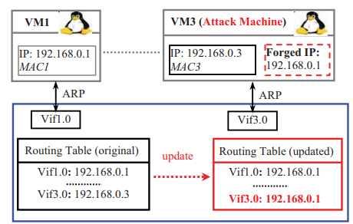

VIII. RESULTS

The exploration given in the Topological Analysis of TCP/IP Connectivity concentrates fundamentally builds the investigation model's capacity to address true organizations.

Wireless Network Security and Interworking: From this we discovered that lack of definition doesn't ensure security and that ad libbed arrangements simply add to the issue. All things considered;

Network Security for Virtual Machine in Cloud Computing: The security of virtual organizations, a center innovation of cloud stages, is the subject of this article. In light of the examination of Xen, it has offered a novel virtual organization system to expand the security of between correspondence among virtual machines conveyed in genuine PCs.

Research on the Key Technologies of Network Security-Oriented Situation Prediction zeroed in on network security circumstance forecast and propose a PSO-LSTM brain network-based calculation for foreseeing network security circumstances.

To sum up, the Research on Computer Network Security adds to a superior comprehension of PC network firewall innovation. Innovation for dynamic parcel sifting. Through a firewall, capturing packets is conceivable. Data about the Application Layer is removed.

Priyank Sanghavi, Kreena Mehta , Shikha Soni-Network Security: As the web fills in prominence, network security is turning out to be progressively significant. To assess the essential changes in security innovation, the security dangers and web convention were broke down. Albeit most security innovation is programming based, various famous equipment gadgets are utilized.

IX. CONCLUSION

We assessed various researchers in the general concepts in network security, Penetrating Attacks and Possible Security Mechanisms, the technologies involved in this field and the approaches to network security in WSN, TCP/IP Connectivity, Spectral Fingerprints, Cloud Computing, Lightning Network Payments, Security-Oriented Situation Prediction and Firewall Technology in this report. A considerable lot of the ongoing security advancements depend on the very arrangement of safety innovation that is currently being used, with little changes.

X. ACKNOWLEDGEMENT

We would like to thank every one of the people who added to the papers which we took for making this article. We also like to stretch out our genuine gratitude to all people for their skill and help all through all parts of our review and for their assistance recorded as a hard copy the composition.

XI. REFERENCES

1. Rene Pickhardt , Sergei Tikhomirov , Alex Biryukov , and Mariusz Nowostawski- Security and Privacy of Lightning Network Payments with Uncertain Channel Balances
2. Xinzhou He 2021 J. Phys.: Conf. Ser. 1744042037
3. Priyank Sanghavi, Kreena Mehta, Shikha Soni (2018); Network Security; Int J Sci Res Publ 3(8) (ISSN: 2250-3153).
4. Y Bingyu. An Elementary Introduction to Computer Network Security [J]. Computer Knowledge and Technology.
5. X Deqin, Z Quan, Z Min, P Chunhua, Z Mingwu. Computer Network Principle and Applications [R]. Beijing: National Defense Industry Press.
6. Q Yi. A Study on the Identification Authentication of Network Security [J]. Journal of Huaihai Institute of Technology.
7. S Yongjie. Research on Communication Encryption Technology of Network Security [J]. Telecom Power Technology.
8. Dowd, P.W.; McHenry, J.T., "Network security: it's time to take it seriously,"
9. Kartalopoulos, S. V., "Differentiating Data Security and Network Security," Communications.